**MY SQL QUERIES**

**CHOCOLATE SALES PROJECT**

**DATA CLEANING**

**CONVERT DATE (transaction_date) COLUMN TO PROPER DATE FORMAT**

**Create a new column for cleaned numeric amount**

**ALTER TABLE [dbo].[Chocolate Sales]**

**ADD Amount_USD DECIMAL(10,2);**

**-- Remove $ and commas, convert to decimal**

**UPDATE [dbo].[Chocolate Sales]**

**SET Amount_USD = CAST(REPLACE(REPLACE(Amount, '$', ''), ',', '') AS DECIMAL(10,2));**

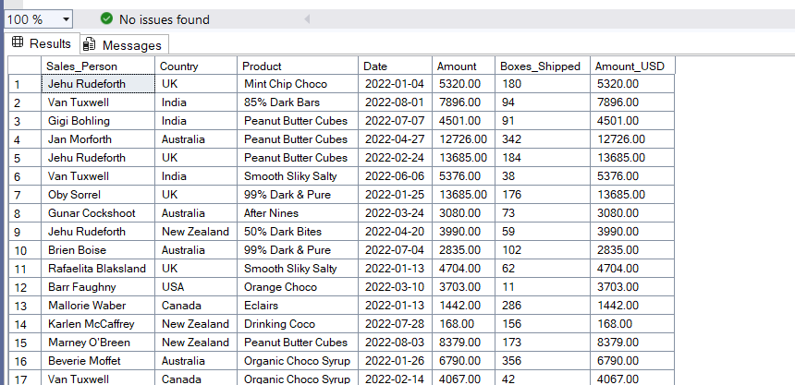

**-- Remove Amount_USD column**

**ALTER TABLE [dbo].[Chocolate Sales]**

**DROP COLUMN Amount_USD;**

**🧩 Business Problem:**

**"How can the chocolate company improve its sales strategy by identifying top-performing products, regions, and salespeople, while optimizing shipment volumes and revenue efficiency?"**

**🎯 Business Objectives:**

1. **📈 Boost Revenue  
   Identify which products and regions drive the most revenue.**
2. **📦 Optimize Shipping Efficiency  
   Analyze how many boxes are being shipped versus how much revenue is being generated.**
3. **🏆 Track Salesperson Performance  
   See which sales reps contribute the most revenue and highest average sale value.**
4. **📍 Uncover Regional Trends  
   Compare sales performance across countries and identify high-potential markets.**
5. **📅 Analyze Time-Based Sales Patterns  
   Spot trends, seasonality, or dips over time (by month, quarter, etc.).**

**DATA ANALYSIS**

**1)TOTAL REVENUE**

**SELECT SUM(Amount) AS Total_Revenue**

**FROM [dbo].[Chocolate Sales];**

**2)TOTAL AVERAGE ORDER VALUE**

**SELECT AVG(Amount) AS Avg_Order_Value**

**FROM [dbo].[Chocolate Sales];**

**3)TOTAL BOXES SHIPPED**

**SELECT SUM([Boxes_Shipped]) AS Total_Boxes_Shipped**

**FROM [dbo].[Chocolate Sales];**

**4)AVERAGE BOXES PER ORDER**

**SELECT**

**CAST(SUM([Boxes Shipped]) * 1.0 / COUNT(*) AS DECIMAL(10,2)) AS Avg_Boxes_per_Order**

**FROM [dbo].[Chocolate Sales];**

**5)TOTAL ORDERS**

**SELECT COUNT(*) AS Total_Orders**

**FROM [dbo].[Chocolate Sales];**

**6)MONTHLY TREND FOR REVENUE**

**SELECT**

**DATENAME(MONTH, [Date]) AS Month_Name,**

**SUM(Amount) AS Total_Revenue**

**FROM [dbo].[Chocolate Sales]**

**GROUP BY DATENAME(MONTH, [Date]);**

**7)% OF REVENUE BY PRODUCT**

**SELECT**

**Product,**

**CAST(SUM(Amount) AS DECIMAL(10,2)) AS Total_Revenue,**

**CAST(SUM(Amount) * 100.0 / (SELECT SUM(Amount) FROM [dbo].[Chocolate Sales]) AS DECIMAL(10,2)) AS Revenue_Percentage**

**FROM [dbo].[Chocolate Sales]**

**GROUP BY Product**

**ORDER BY Total_Revenue DESC;**

**8)BOXES SHIPPED BY COUNTRY**

**SELECT**

**Country,**

**SUM([Boxes_Shipped]) AS Total_Boxes_Shipped**

**FROM [dbo].[Chocolate Sales]**

**WHERE MONTH([Date]) = 2 -- Example: February**

**GROUP BY Country**

**ORDER BY Total_Boxes_Shipped DESC;**

**9)TOP 5 PRODUCTS BY REVENUE**

**SELECT TOP 5**

**Product,**

**SUM(Amount) AS Total_Revenue**

**FROM [dbo].[Chocolate Sales]**

**GROUP BY Product**

**ORDER BY Total_Revenue DESC;**

**10)BOTTOM 5 PRODUCTS BY REVENUE**

**SELECT TOP 5**

**Product,**

**SUM(Amount) AS Total_Revenue**

**FROM [dbo].[Chocolate Sales]**

**GROUP BY Product**

**ORDER BY Total_Revenue ASC;**

**11)TOP 5 SALESPEOPLE BY REVENUE**

**SELECT TOP 5**

**[Sales Person],**

**SUM(Amount) AS Total_Revenue**

**FROM [dbo].[Chocolate Sales]**

**GROUP BY [Sales Person]**

**ORDER BY Total_Revenue DESC;**

**12)DAILY TREND FOR TOTAL ORDERS**

**SELECT**

**DATENAME(WEEKDAY, [Date]) AS Order_Day,**

**COUNT(*) AS Total_Orders**

**FROM [dbo].[Chocolate Sales]**

**GROUP BY DATENAME(WEEKDAY, [Date]);**

